Light Energy
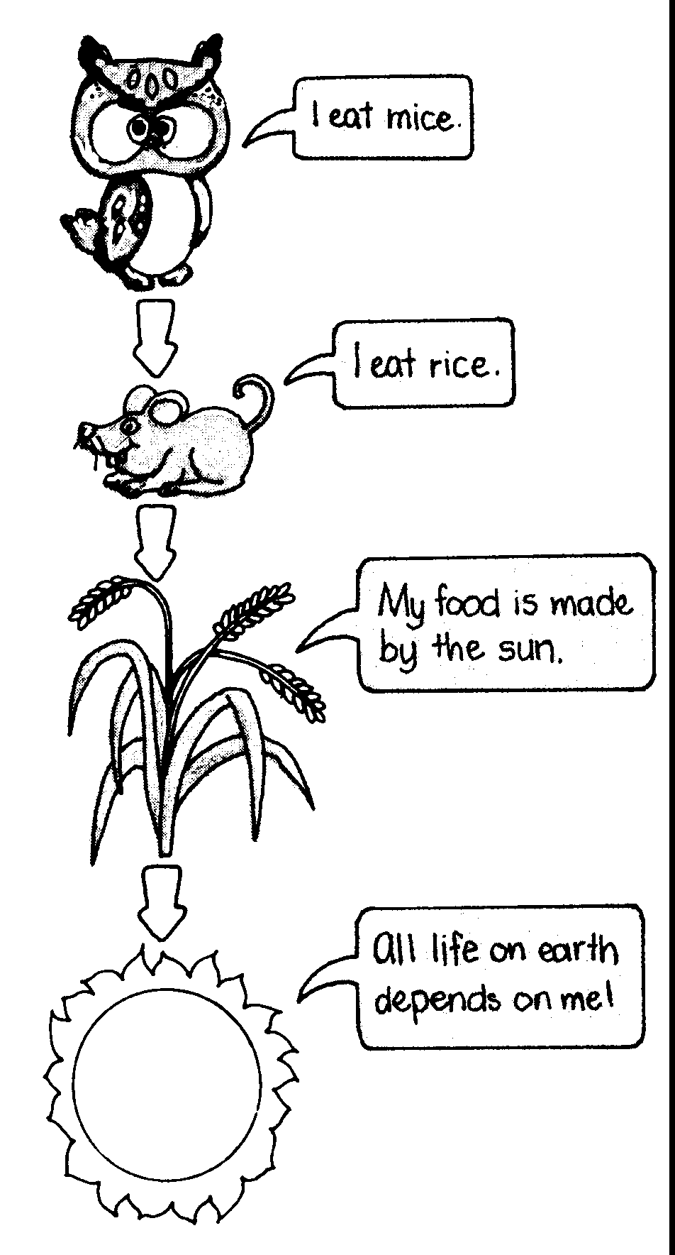

If you can read this, you are relying on light energy. Light energy and our eyesight are the two things we need to be able to see; without one or the other there would be no sight.
Can you imagine what life would be like without light energy? Quite simply, there would not be any life at all. Plants need light to live and if there were no plants, there would be no animals, including people.

Sources of Light

Light energy is one of the forms of radiant energy that comes to us from
the Sun. This light energy is formed in nuclear reactions that occur within the Sun.
Other objects and substances can also give off their own light energy. These objects
are said to be luminous. The light carries energy away from luminous objects as electromagnetic waves.

1. Give examples of objects or substances that are luminous.

Many light sources emit light energy because they are hot. However, there are light sources which give out light without getting hot. These include fluorescent tubes, the paint on the hand and numerals of clocks, fireflies and some deep sea fish.

2. Which of your examples given in a) emit light energy because they are hot?
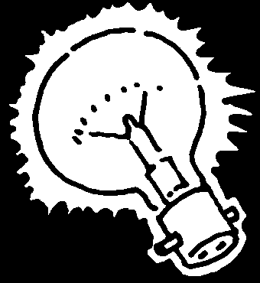

3. Draw energy flow charts to show where the light energy comes from for the following objects:
a) a candle
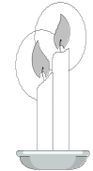

b) a torch

c) an electric light bulb

4. Most things that can be seen are not luminous. For example, you can see this page and the writing on it yet they do not produce their own light.
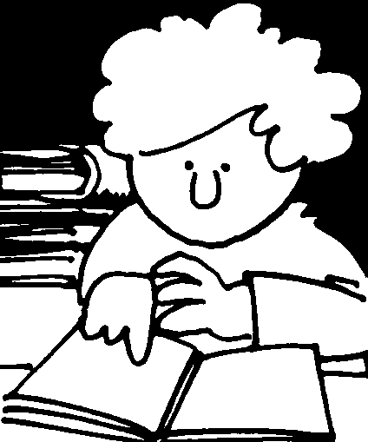
a) Explain why you can see this page even though it does not emit its own light energy.

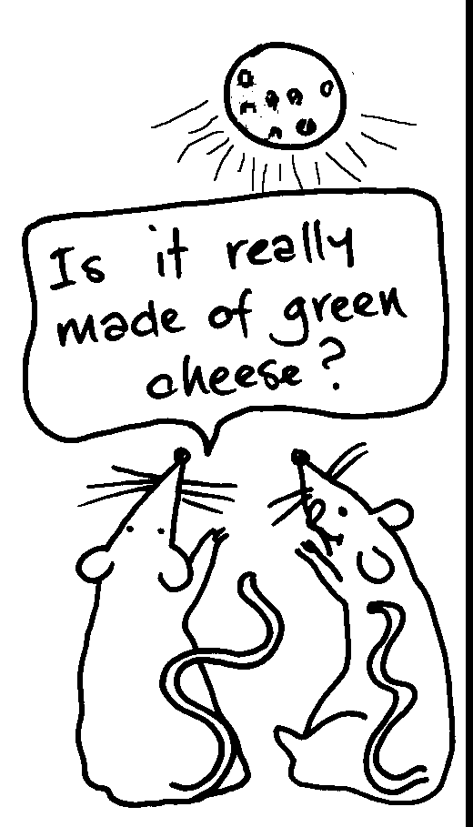

b) Explain why the Moon shines brightly in the night sky.

How light travels
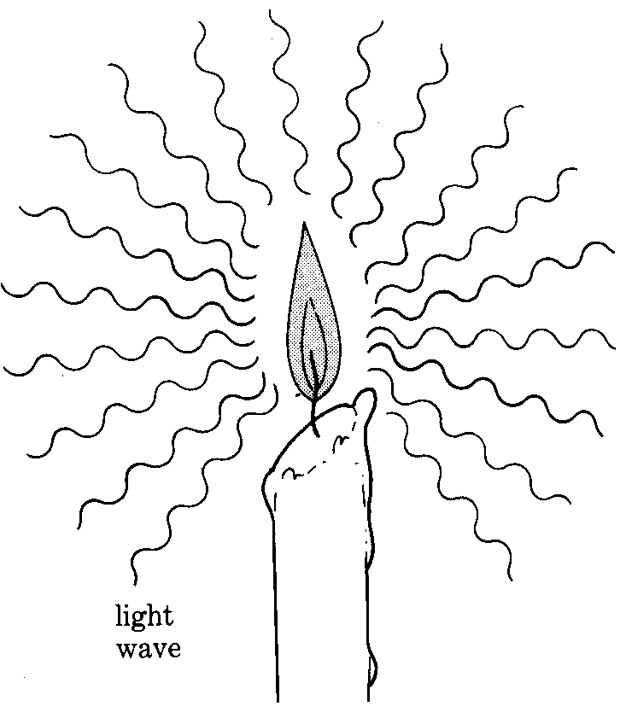
One scientific theory proposes that light energy travels in a wave motion. The light that we can see has a wavelength of about th of a millimetre. Light energy travels at a speed of about 300 million metres per second.
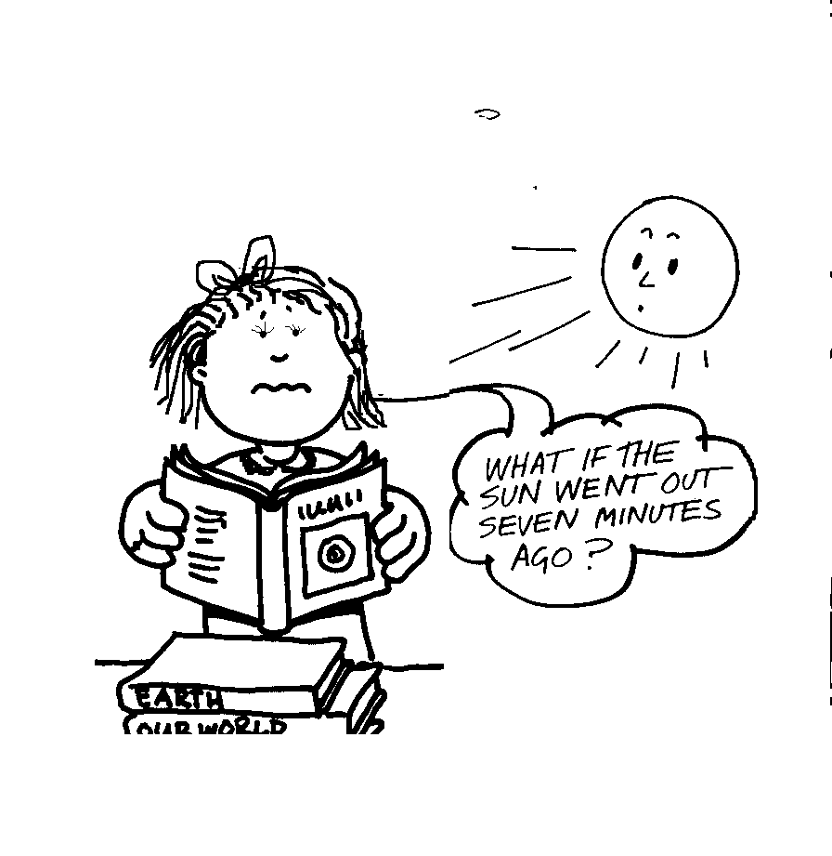

1. If the Sun is 150 million kilometres away from the Earth, how long does it take light energy from the Sun to reach Earth?

2. Approximately how long would it take for light to travel across the M.L.C. oval?

Although light cannot normally be seen as it passes through air, conclusions can be made about how it travels. For example, light will travel in a straight line unless some other substance is placed in its path.

3. Can you see around a corner of a brick building? (without the aid of mirrors). Explain your answer.

4. a) Cut out a shape from a piece of cardboard. b) Hold your shape in front of a light source.
Sketch your shape below. Sketch the shape of the shadow it produces.

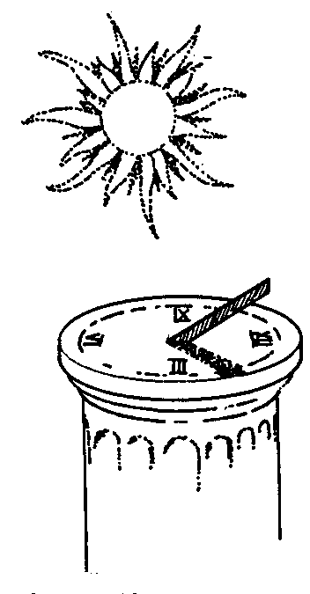
c) Explain the shape of the shadow. Include a diagram showing what has happened to the "rays" of light (a ray diagram).
(In diagrams, lines called rays are used to show the direction in which the light energy is traveling. A light ray can be thought of as a very narrow beam of light.)

d) Repeat the experiment described in a) and b), but this time cut the shape out of an overhead projection sheet.
What happens?
Explain your observations. Again, use a ray diagram to show what is happening to the light energy.

When light energy hits an object, several different things can happen. What happens depends on the substance making up the object. Some substances allow light energy to pass through them. Other substances will not allow light energy to pass through and either reflect (bounce off) or absorb the energy.

5. a) i) What name is given to materials which allow light to pass through?

ii) Give three examples of such materials.

iii) What name is given to materials which will not allow light to pass through?

iv) Give two examples of such materials - one which reflects the light, and one which absorbs the light.

Reflection of light energy

When light energy strikes an object, some of the energy is absorbed and some bounces off. The reflected waves which bounce off the object enable us to see it.

6. Draw a diagram showing the path of the light energy that enables us to see a book which is lit by a desk lamp. Show the direction of the light energy.
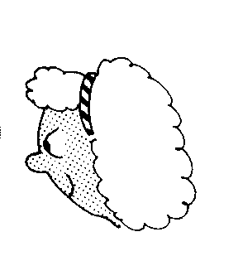
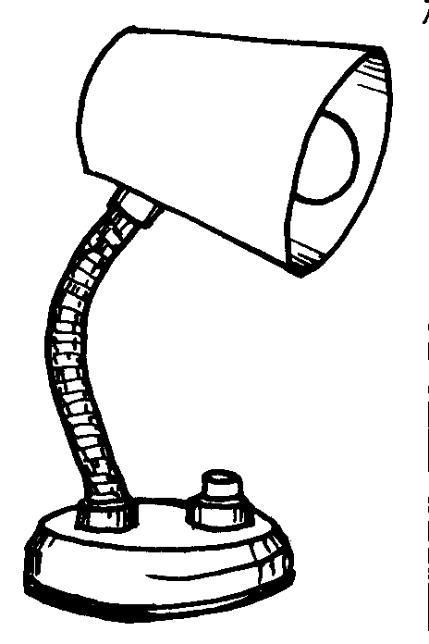

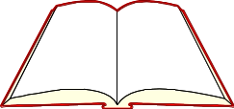

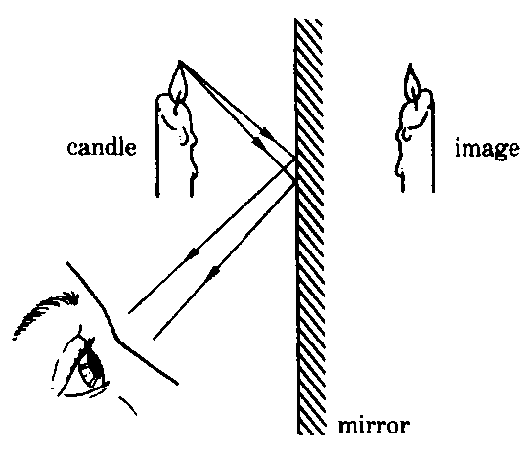
7. When you look at an object in a flat mirror, you see an image. A mirror reflects the light from an object and makes the image which we see.

Write a short word on a piece of paper, then look at the word in a mirror. What does the image of your word look like?

Select the correct words in the following sentences to summarise your observations:

- The image is the same way up or upside down compared to the word written on the paper.
- The image is the same size as or smaller than or larger than the word written on the paper.
- The letters and word in the image are the same as or reversed compared to the word written on the paper.

8. Write the word AMBULANCE as it would be painted on the front of an ambulance so a driver looking at it through a car mirror would read it correctly.
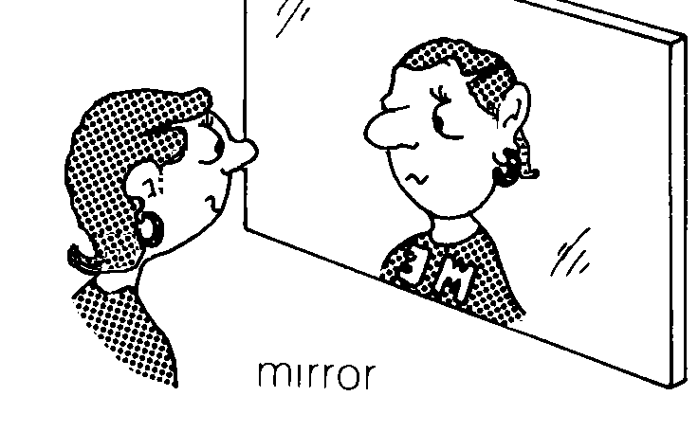

Absorption and reflection of light

Although sunlight appears to be white, it is not actually a single pure white colour. It is made up of seven different colours that you can see, called the visible spectrum. The colours of the visible spectrum are red, orange, yellow, green, indigo and violet. Each of these colours correspond to light of different wavelengths with red light having the longest wavelength and violet light having the shortest wavelength.

Different materials absorb some of the colours in sunlight (white light) and reflect others. The colour we see in an object depends on the colours that are reflected back to our eyes. For example, a yellow object absorbs all colours except yellow, and it reflects yellow.

White objects appear white because they reflect all the colours of sunlight, but black objects appear black because they absorb all the colours and reflect none.

9. Using coloured pens or pencils, colour and complete the following diagrams, showing the colour of the leaf and of the bananas, and the different colours in the sunlight (white light) and in the reflected light.

white light
white light

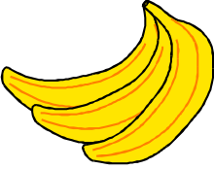
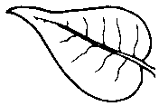

yellow bananas

green leaf

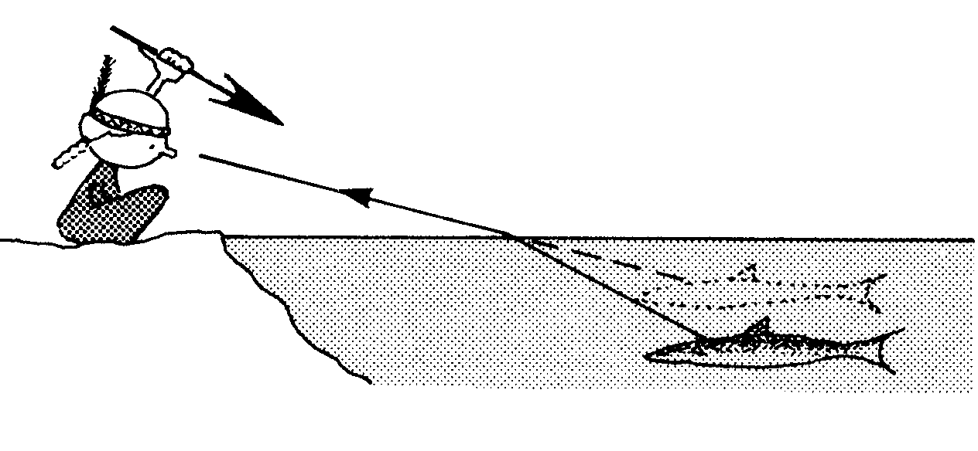

Bending of light

10. Place a coin in an empty cup and move your eyes until it is just out of view. Ask your partner to carefully fill the cup with water. What happens to the coin?

11. Put a pencil in a beaker of water. Look at the pencil from the side of the beaker. What do you see?

When light energy meets a new substance, the light changes direction or bends. When light bends going from one substance to another, we say that the light is refracted. The light bends when going from one substance to another because it moves at different speeds through different materials. It travels slower through water and glass than it does through air.

